* **Instruction for setting up the application:**

Initially unzip the prj2 file, then follow the steps to run the project.

Required database (MySql) script is under DB_files folder.

First run the tables file and then sp file

Project is named as “Project 1” in folder pro

Open Project 1 file in Visual Studio. Project is created in Visual Studio 2017(.net framework 4.5)

Go to the solution explorer under Project 1 there is a main folder expand it. Then open index.html file and run the project in Google Chrome.

Wait till the web page gets loaded.

In the tree representation, you will see the whole dataset of “Crescent”.

On the left side of the tree there is the Parent Node Called as “**doc**”. From where you can add a new data which will be added as a child node. All nodes are alphabetically sorted. So, when you click on the doc node, a form for adding new data will pop up. The Whole data is sorted with the help of branch node and the child node,

When you click on child node you will see the data of that child. When you left click on the same child it will ask you to edit the child data and when you do right click there itself it will ask you delete option. After deletion the child node will turn green. To notify that the node is deleted. To Retrieve the node again do right click on deleted node, so retrieve option will popup, and that’s how you retrieve the node.

* **Working of System**:

We have compared two data sets.

1. Crescent dataset
2. Suspects Dataset

In this comparison, for the given data in crescent file which matches with the part of the suspects data will be taken as a Actual suspect and shown in the tree as red dot.

When you scroll the by dragging the screen up and down you can see there are some red child nodes in it. That is the result of system. And that’s how we found the actual suspects.

* **We also added a video of our web application.**

* **Who are the key suspicious persons?**

According to our survey using tool we developed, the planning of the potential threat is done by Abdul Ramazi/Muhammed bin Harazi. There are people who have done blast is by Hans Pakes/Abu al Masri and Bhagwant Dhaliwal/Sahim Albakri

Screen shot to support this answer:

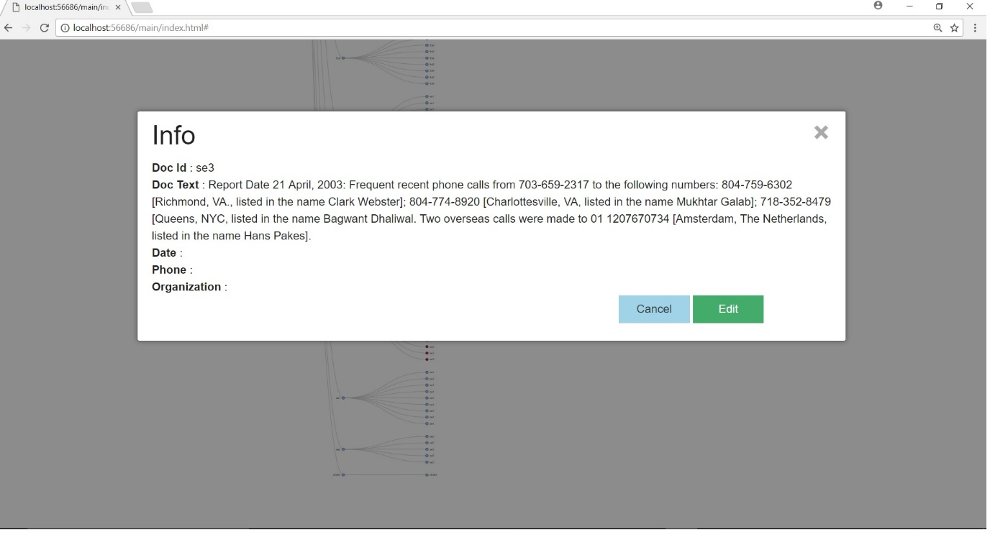

* **What are they attacking targets?**

In our view the attacking targets will be Boston, NYC, Atlanta because the suspected Holland Queen ship carrying the explosives in travelling towards Boston, Bhagwant Dhaliwal/Sahim Albakri our suspect for this explosion is in NYC and picked the explosive in NYC and Faysal Goba/Zaid Al Shibh, Mukhtar Galab and Yasein Mosed are travelling to Atlanta with C4 in the train respectively.

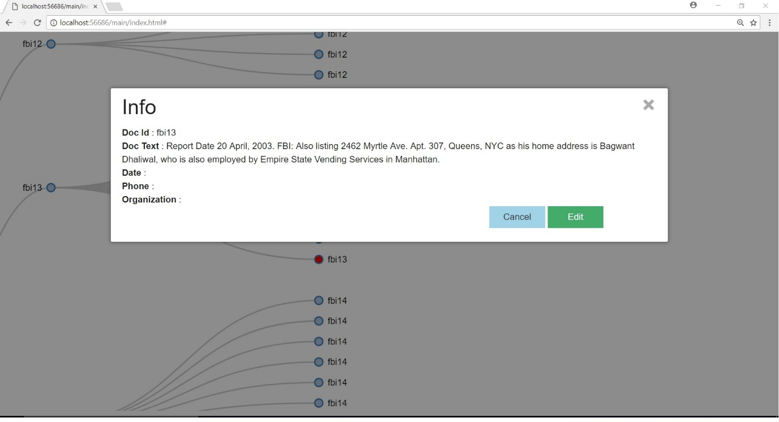

* **When will their planned attacks happen?**

According to our survey in Boston the attack might happen on 29th April 2003 because Holland queen is arriving to Boston on the same date. In NYC it would be on 28th-29th April 2003 because Bhagwant Dhaliwal/Sahim Albakri picked explosives on 25th. And we have all the reports until 27th so the explosion should have been on 28/29th as he must meet Abdul Ramazi/Muhammed bin Harazi on 30th.In Atlanta it will be on 29th / 30th April 2003 because on that day Faysal Goba/Zaid Al Shibh, Mukhtar Galab and Yasein Mosed arrives Atlanta.

4